Lab7

***************************************************
The usage of matlab modules
***************************************************

>> normcdf(0)

ans =

0.5000

>> normcdf(-1.96)

ans =

0.0250

>> normcdf(1.96)

ans =

0.9750

>> normcdf(-1.645)

ans =

0.0500

>> normcdf(1.645)

ans =

0.9500

>> 1-normcdf(1.96)

ans =

0.0250

>> normcdf(1.96)-normcdf(-1.96)

ans =

0.9500

>> normcdf(-1.96)+1-normcdf(1.96)

ans =

0.0500

>> normcdf(-3)

ans =

0.0013

>> normcdf(-3)+1-normcdf(3)

ans =

0.0027

>> normcdf(1)-normcdf(-1)

ans =

0.6827

>> normcdf(2)-normcdf(-2)

ans =

0.9545

>> normcdf(3)-normcdf(-3)

ans =

0.9973

>> 1-(normcdf(3)-normcdf(-3))

ans =

0.0027

>> normcdf(-1.96)

ans =

0.0250

>> norminv(0.025)

ans =

-1.9600

***************************************************
For normal distribution
***************************************************

>> x=randn(10,1)

x =

-0.4326
-1.6656
0.1253
0.2877
-1.1465
1.1909
1.1892
-0.0376
0.3273
0.1746

>> n=length(x);

>> i=[1:n]'

i =

1
2
3
4
5
6
7
8
9
10

>> in=i/(n+1)

in =

0.0909
0.1818
0.2727
0.3636
0.4545
0.5455
0.6364
0.7273
0.8182
0.9091

>> ex=norminv(in)

ex =

-1.3352
-0.9085
-0.6046
-0.3488
-0.1142
0.1142
0.3488
0.6046
0.9085
1.3352

>> xs=sort(x)

xs =

-1.6656
-1.1465
-0.4326
-0.0376
0.1253
0.1746
0.2877
0.3273
1.1892
1.1909

>> plot(ex,xs,'*')

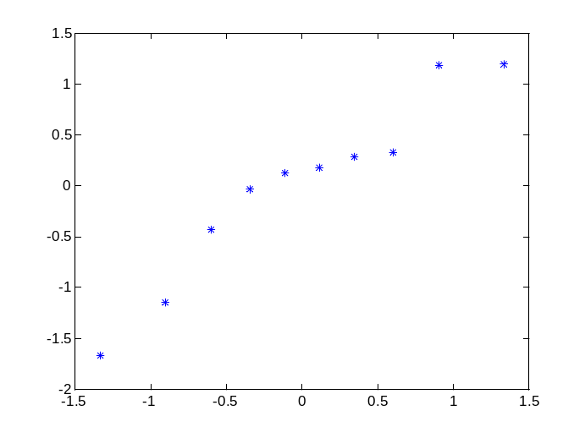
% We can say roughly that there is more or less a straight line.

>> corr(ex,xs)

ans =

0.9640

% Tabulated value of Table 4.2 for n=10 alpha=0.05 is 0.9198. Thus, we fail to reject normality.

***************************************************
Creating a bivariate normal distribution and checking bivariate normality by using the Mahalanobis distances.
***************************************************

>> mu=[-1 1];
>> sigma=[2 1;1 3];
>> randn('state',0)
>> x=mvnrnd(mu,sigma,10)

x =

-1.6117 0.3989
-3.3555 0.9698
-0.8228 0.1584
-0.5932 4.6553
-2.6214 -0.0263
0.6842 2.0222
0.6817 3.5276
-1.0532 1.0671
-0.5371 1.0802
-0.7530 -0.1926

>> y=mahal(x,x)

y =

0.4086
4.0006
0.9200
4.8940
1.6898
1.8135
2.3758
0.0383
0.3008
1.5586

>> n=length(y);
>> i=[1:n]';
>> in=i/(n+1);

>> ex=chi2inv(in,2)

ex =

0.1906
0.4013
0.6369
0.9040
1.2123
1.5769
2.0232
2.5986
3.4095
4.7958

>> ys=sort(y)

ys =

0.0383
0.3008
0.4086
0.9200
1.5586
1.6898
1.8135
2.3758
4.0006
4.8940

>> plot(ex,ys,'*')

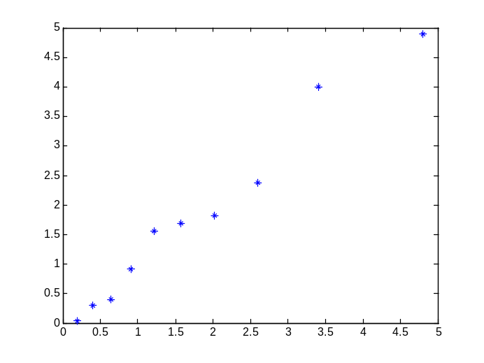

***************************************************
We can say that the Mahalanobis distances have chisquare distribution with 2 degrees of freedom which means that there is an underlying bivariate normal distribution.
***************************************************

***************************************************
To illustrate the usage of Q-Q plot for a distribution with known cumulative distribution function, we will first simulate values from exponential distribution and then we will prepare a Q-Q plot to check whether there is an underlying exponential distribution.
***************************************************

>> clear all

>> beta=2

beta =

2

>> n=10

n =

10

% we can use Matlab modules as below

>> x=exprnd(beta,n,1)

x =

0.4098
0.1979
4.1273
0.1812
0.9166
4.6550
2.5567
1.2070
0.0868
0.0715

% or we can simulate values manually by using
% the inverse cdf as below

>> rand('state',0)
>> u=rand(n,1)

u =

0.9501
0.2311
0.6068
0.4860
0.8913
0.7621
0.4565
0.0185
0.8214
0.4447

>> x=-beta*log(1-u)

x =

5.9966
0.5257
1.8671
1.3310
4.4383
2.8718
1.2193
0.0374
3.4453
1.1765

***************************************************
The expected values for a q-q plot are always evaluated for standardized variables but the unstandardized sorted variables are used. This is in fact an advantage of the method since no location and scale parameter have to be estimated. The Q-Q plot is location and scale invariant. ***************************************************

>> i=[1:n]'

i =

1
2
3
4
5
6
7
8
9
10

>> in=i/(n+1);

% we can use Matlab modules as below

>> ex=expinv(in,1)

ex =

0.0953
0.2007
0.3185
0.4520
0.6061
0.7885
1.0116
1.2993
1.7047
2.3979

% or we can obtain values manually by using
% the standardized inverse cdf as below

>> ex=-log(1-in)

ex =

0.0953
0.2007
0.3185
0.4520
0.6061
0.7885
1.0116
1.2993
1.7047
2.3979

>> x

x =

5.9966
0.5257
1.8671
1.3310
4.4383
2.8718
1.2193
0.0374
3.4453
1.1765

>> xs=sort(x)

xs =

0.0374
0.5257
1.1765
1.2193
1.3310
1.8671
2.8718
3.4453
4.4383
5.9966

>> plot(ex,xs,'*')

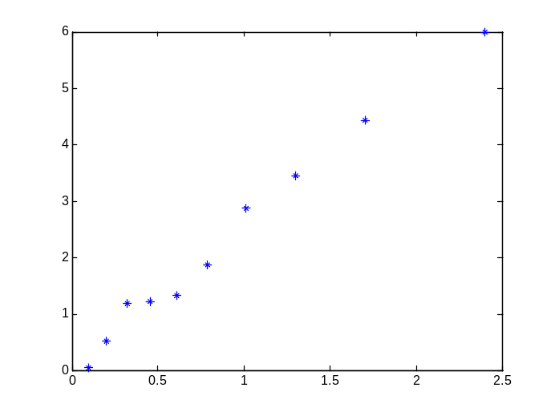

***************************************************
We can roughly say that there is an underlying exponential distribution.
***************************************************

